**ICMSS-1 ABSTRACT TEMPLATE**

Paper presenters are requested to use the following simple template when submitting their Abstracts:

Title (Times New Roman, Size 14)

Author’s Name (Size 12)

Affiliation with Email Address (Size 12)

Abstract (Size 12)

Keywords (Size 12) – not more than five (5)

===============================================================

**Remark**: Submission of Abstracts is being received through the EasyChair system.

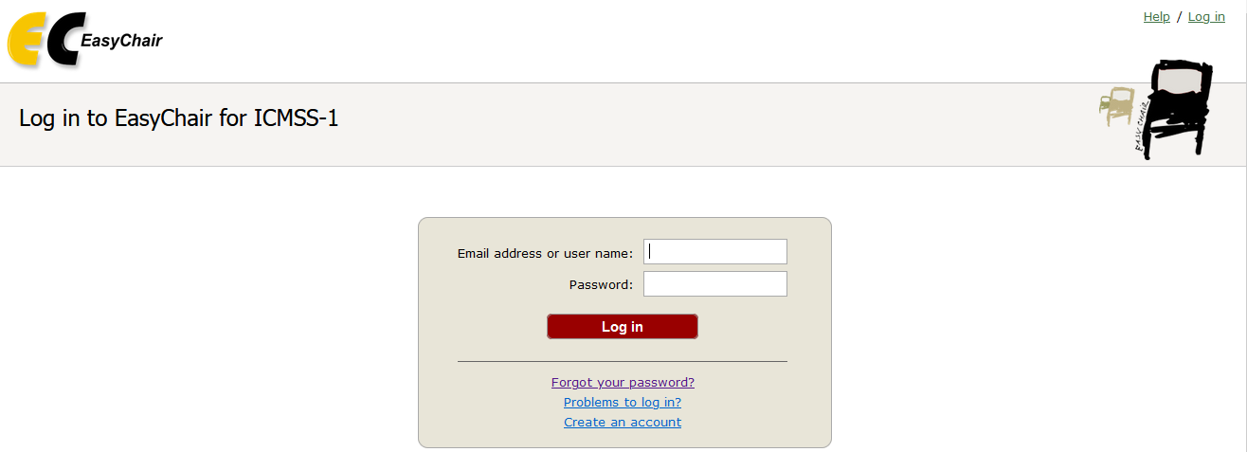

An author without EasyChair account will be required to create an account and to add ICMSS-1 in order to submit their Abstract.